/\*

Name: Ashok Rathod

Class lab: selecting and grouping data lab work

Date: 4.13.19

\*/

SQLzoo quiz sum and count

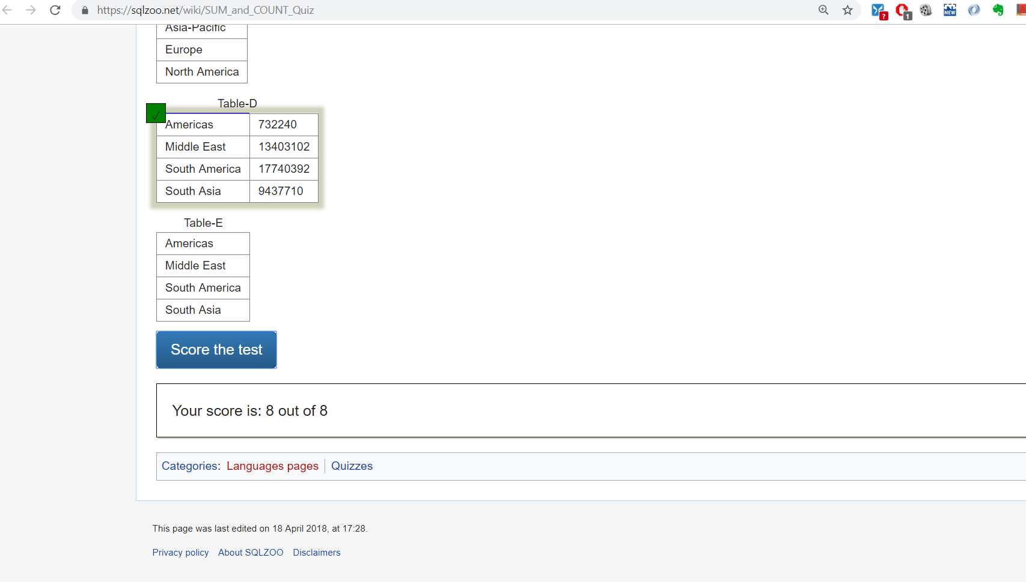

BI facts

